Branch: MCA (Data Science) | Semester: 2
Student Name: Adarsh Mishra | UID: 25MCD10065
Subject Name: Technical Training - I | Subject Code: 25CAP-652
Section/Group: 25MCD – 1(A) | Date of Performance: 27 January,2026

Experiment No. : 3

- Aim/Overview of the practical:
To implement conditional decision-making logic in PostgreSQL using IF–ELSE constructs and CASE expressions for classification, validation, and rule-based data processing.

Tools Used
PostgreSQL

- Objective:
  - To understand conditional execution in SQL
  - To implement decision-making logic using CASE expressions
  - To simulate real-world rule validation scenarios
  - To classify data based on multiple conditions
  - To strengthen SQL logic skills required in interviews and backend systems

- Code for experiment/Practical:

CREATE TABLE dept_violations (
dept_id SERIAL PRIMARY KEY,
dept_name VARCHAR(100),
violation_count INT NOT NULL
);
INSERT INTO dept_violations (dept_name, violation_count) VALUES
('HR', 0),
('IT', 2),
('Finance', 5),
('Operations', 1);

--

SELECT
dept_violations,
violation_count,
CASE
WHEN violation_count = 0 THEN 'No Violation'
WHEN violation_count BETWEEN 1 AND 2 THEN 'Minor Violation'
ELSE 'Critical Violation'
END AS violation_category
FROM dept_violations;

--

ALTER TABLE dept_violations
ADD COLUMN approval_status VARCHAR(50);

--

UPDATE dept_violations
SET approval_status =
CASE
WHEN violation_count = 0 THEN 'Approved'
WHEN violation_count BETWEEN 1 AND 3 THEN 'Under Review'
ELSE 'Rejected'
END;

--

Select * from dept_violations;

- Result/Output/Writing Summary

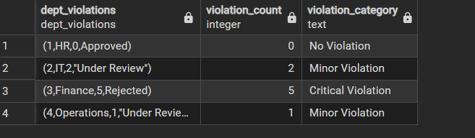

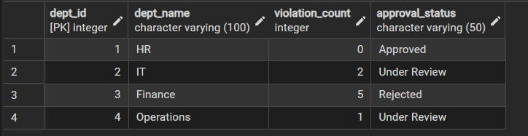

Learning outcomes (What I have learnt):

- Understand how to use CASE expressions to classify data
- Learn to apply conditional logic in SQL for categorizing and evaluating database records.
- Perform automated data updates using CASE inside UPDATE statements.

